**AIN432 Project Report:**

**Image Blending with Laplacian Pyramids**

**Overview**

The goal of this project is to blend images seamlessly using Laplacian Pyramids. Image blending involves combining two images in such a way that the transition between them is smooth and visually appealing. Laplacian Pyramids are employed to achieve this by decomposing images into multiple levels of detail and reconstructing them after blending.

**Approach**

**1. Image Resizing**

The first step is to resize the input images to a consistent size (e.g., 1024x1024) to ensure uniformity in the blending process. This is crucial for maintaining coherence in the result.

**2. Laplacian Pyramids**

Laplacian Pyramids are constructed for both the original images and their center regions. The Laplacian Pyramid represents an image as a series of layers, each containing the difference between the current level and an expanded version of the next level's image.

**3. Center Region Selection**

A central region is selected from each resized image to be blended. This region is resized to 50% of the original size to provide a smooth transition during blending.

**4. Blending**

The Laplacian Pyramids of the original images and their center regions are blended by adding the center of one image to the center of the other at each pyramid level.

**5. Image Reconstruction**

The final step involves reconstructing the blended image from the Laplacian Pyramid.

**Results**

1. Resized Images

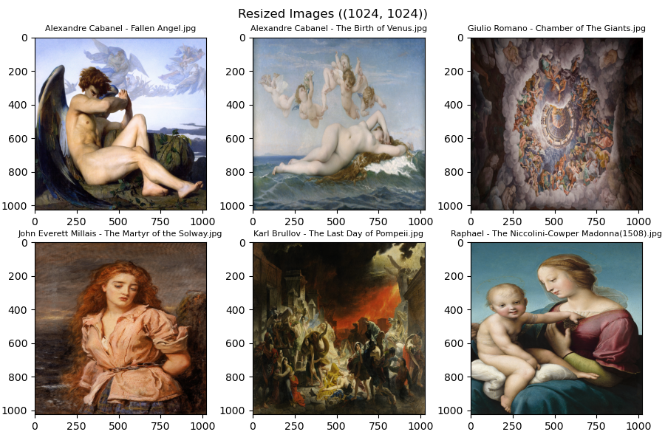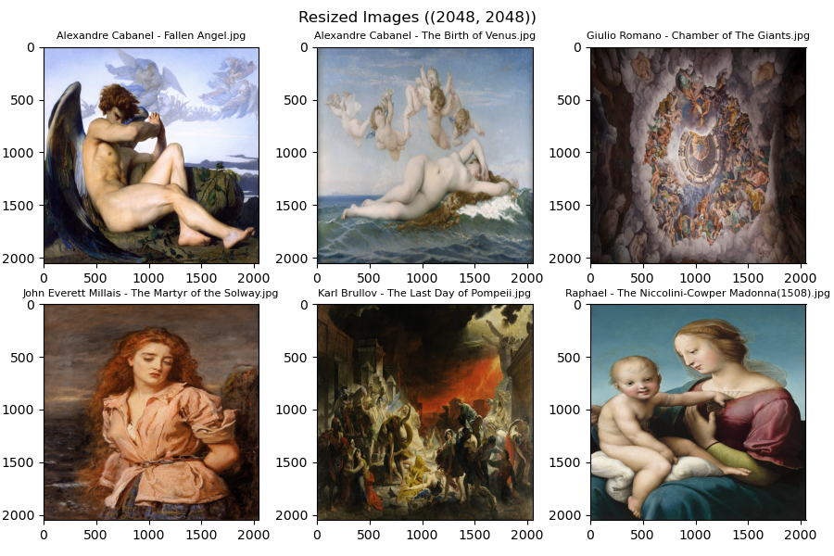

2. Center Region Selection

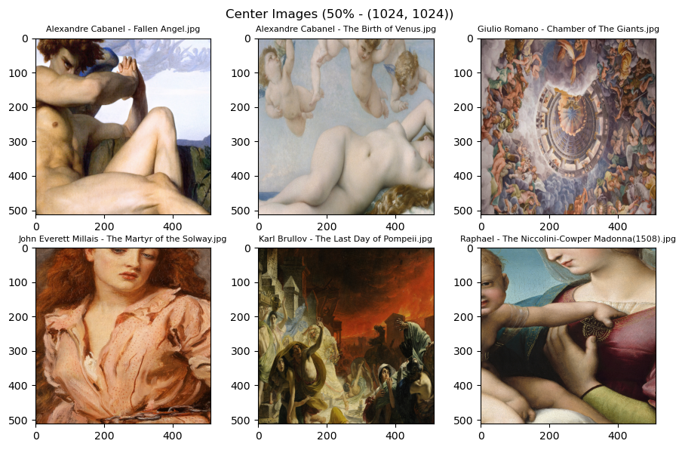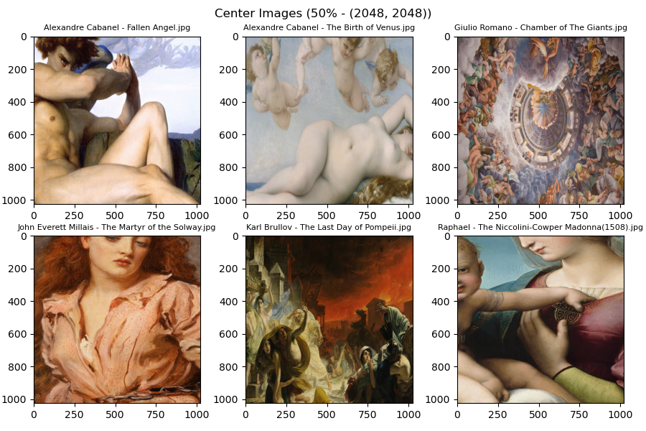

3. Added Images

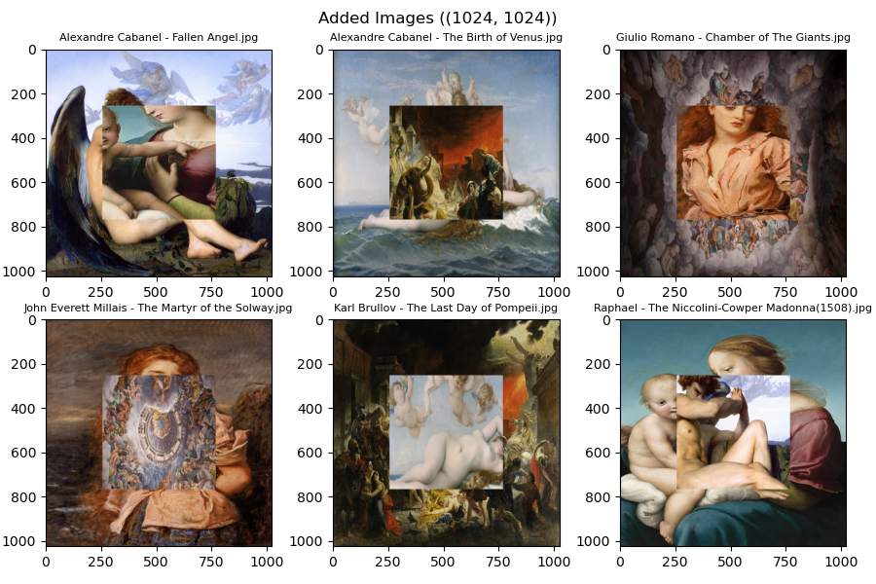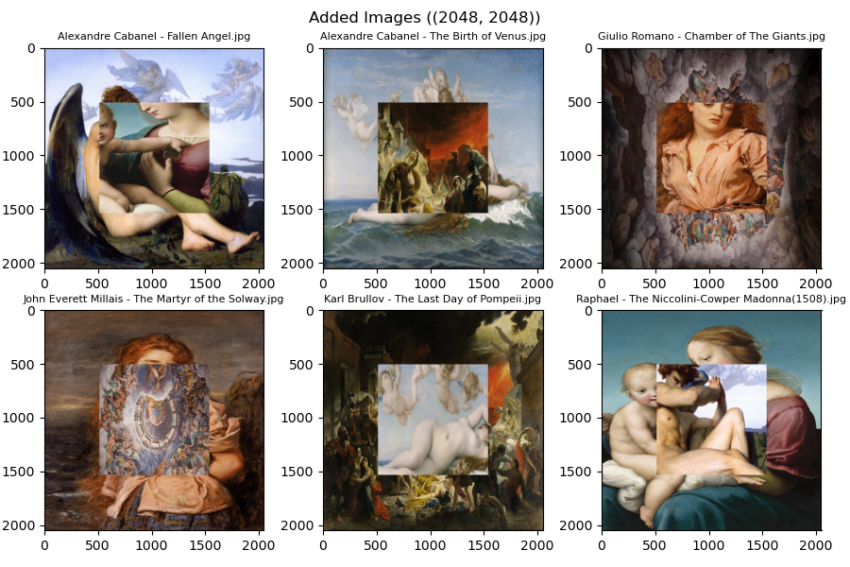

4. Blended Images with Different Laplacian Levels

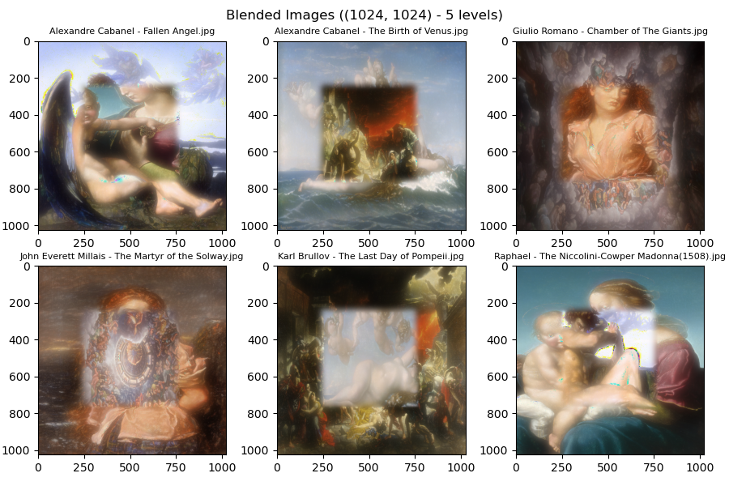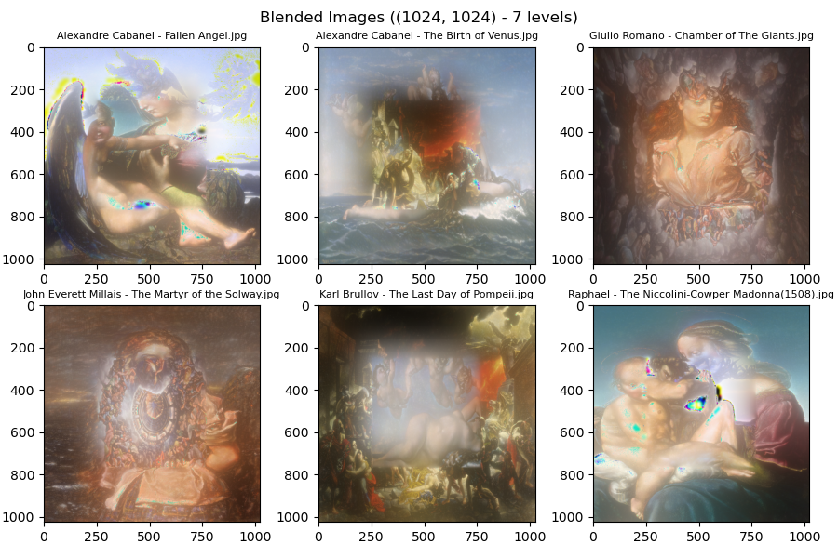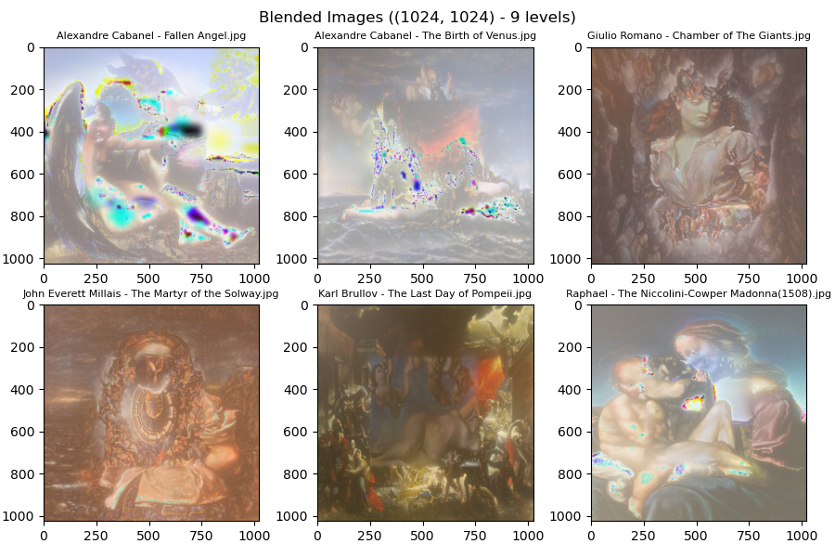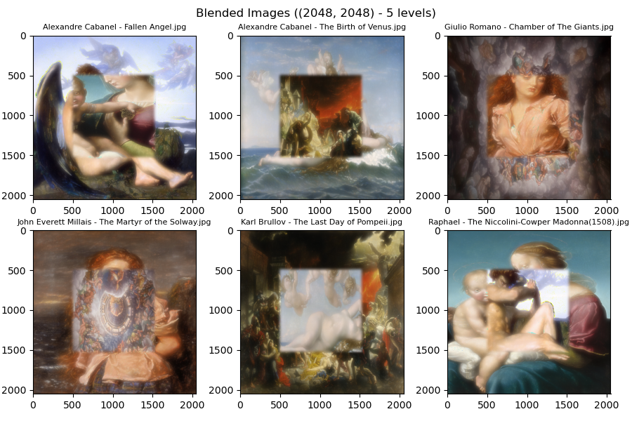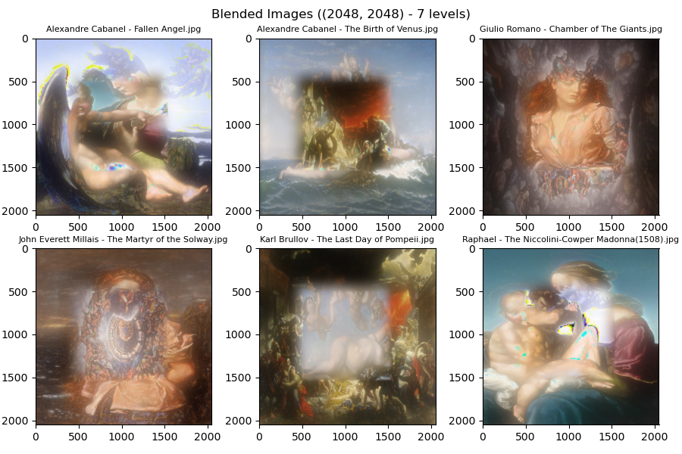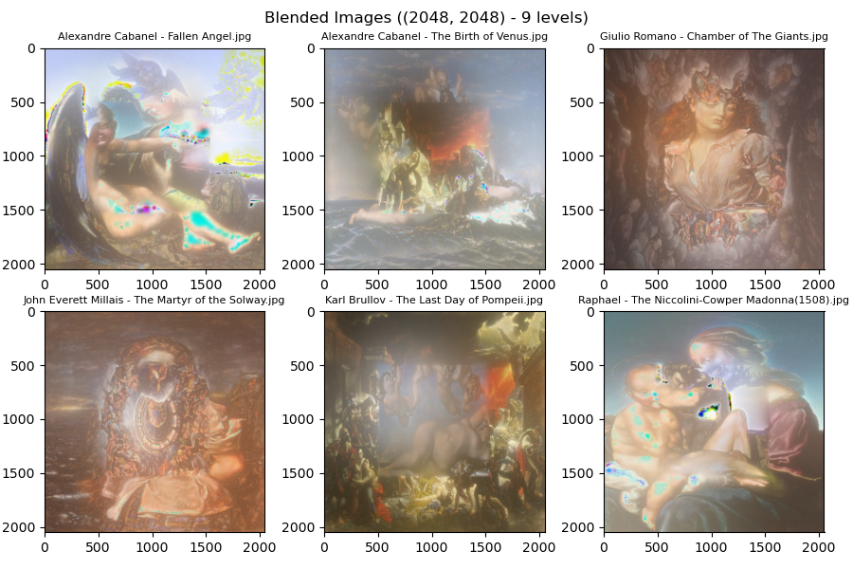

**Discussion**

The algorithm successfully blends images, providing visually appealing results. The use of Laplacian Pyramids ensures smooth transitions between images.

**Conclusion**

In conclusion, the implemented image blending algorithm utilizing Laplacian Pyramids demonstrates satisfactory results in seamlessly combining images.